**Project Proposal**

Instructor: Michael Hrybyk

Due Date: 3/23/2017 at 5:00 pm

Course: CSIS 3540 Client Server Systems

Team Leader: Brandon Frison

Team Members:

Brandon Frison 300 243 731

Harmeet Kaur Sandhu 300 254 467

Qingpeng Li 300 200 825

Project Description

-Our project is a hospital management system that will be able to track data on doctors, patients, medicine inventory, prescriptions, vendor information.

-The project will make use of the ADO.NET entity framework to connect to the database and query it.

-It will have 3 GUI sections for separate user types.

Process Model

User roles:

-Receptionist

-Patient

-Doctor(administrator)

Receptionist can add patients and assign them to a doctor.

Patient can check prescriptions with their patient id only. (read only)

Doctor can add prescriptions, add medicine and all receptionist processes as well.

Database Model

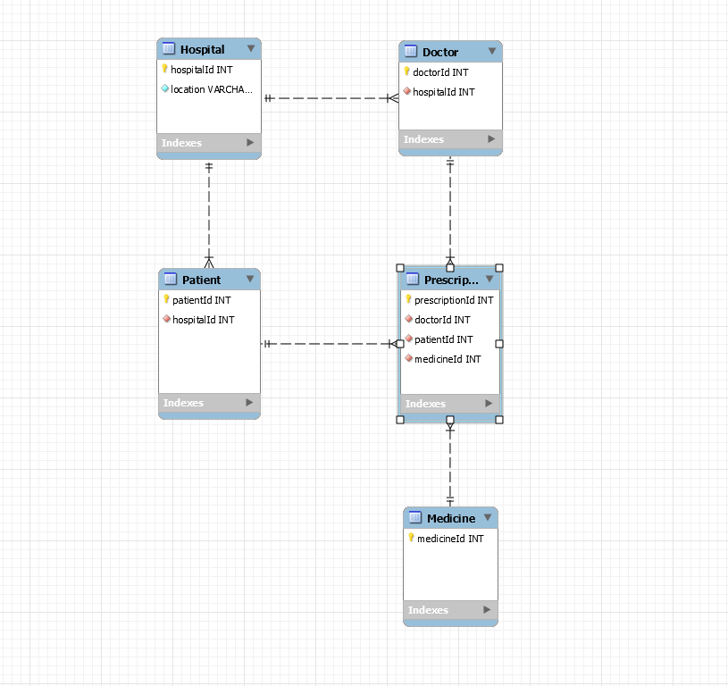ERD diagram shows basic relationships between the tables. More attributes will be added to the final version of the application.

Five tables which are Hospital including room and location information, Doctor and Patient which includes basic data on the occupants at the hospital, Prescriptions which are the basic data records at the hospital and a Medicine table for inventory.

User Interface

Our software will have 4 screens which are one for each separate permission.

The home screen is a login page that redirects to each of these screens upon 3 buttons of user’s choice:

The screen for patients which will show in read only grid views with doctor name, prescription information and have an input for patient user ID.

The screen for doctors or administrators will have much more access including buttons that will add patient prescriptions, add new medicine to inventory.

The screen for receptionists will have the ability to add simple information for inserting new patients and their information.

Project Plan

Main general tasks are creating the GUI screens(1), creating the database using EF(2), Coding the LINQ queries for each separate GUI screen depending on the permission(3).

Other tasks include handling all possible user input errors(3), testing the code and inputs(1), and all database to c# integration will be handled(2).

*all tasks labeled with 1 will be completed by Harmeet, 2 will be completed by Qingpeng, 3 will be completed by Brandon.